**Identify the bands**

# Aim:

The aim of this set of tasks is to give students the opportunity to identify the most significant bands of any IR spectrum by interpreting different IR spectra of a variety of organic compounds.

**Learning outcomes:**

After completing this set of tasks, students will be able to:

1. match the most significant absorption bands with the corresponding functional groups;
2. calculate the degree of unsaturation and understand its importance in IR spectroscopy;
3. apply the knowledge from previous tasks in order to identify the absorption bands of an IR spectrum; and
4. know important details about the characteristics of the most common absorption bands and their functional groups,

**Task 1.** **The effect of the homologous series (aldehydes vs. ketones)**

Study the IR spectra of the two compounds: 3- pentanone and benzaldehyde.

Calculate the degree of unsaturation by clicking on the “Calculate” button.   
By using the structural formula of the compound, could you explain the result of your calculation (e.g. in terms of bond order)?  
………………………………………………………………………………………………………………………………………………………………………………………………………………………………………………………………………………………………………………………………………………………………………………………………………………………………………………………………………………………………………………………………………………………………………………………………

Observe the IR spectrum and particularly the highlighted bands.   
Match these bands with the appropriate functional groups. Click on the band’s label and then click on the button that displays the corresponding group.

|  |  |  |
| --- | --- | --- |
| 3- pentanone | | |
| **Band** | **Functional Group** | **Wavenumber (nm-1)** |
| Unknown band 1 |  |  |
| Unknown band 2 |  |  |

|  |  |  |
| --- | --- | --- |
| Benzaldehyde | | |
| **Band** | **Functional Group** | **Wavenumber (nm-1)** |
| Unknown band 1 |  |  |
| Unknown band 2 |  |  |
| Unknown band 3 |  |  |

Compare the frequency vibration of the C=O group in these two compounds (ketone vs. aldehyde).

………………………………………………………………………………………………………………………………………………………………………………………………………………………………………………………………………………………………………………………………………………………………………………………………………………………………………………………………………………………………………………………………………………………………………………………………

Could you explain the reason resulting in different frequencies?  
  
………………………………………………………………………………………………………………………………………………………………………………………………………………………………………………………………………………………………………………………………………………………………………………………………………………………………………………………………………………………………………………………………………………………………………………………………

**Task 2. The effect of the homologous series (alcohols vs. carboxylic acids)**

Study the IR spectra of the two compounds: 3- pentanol and pentanoic acid.

Calculate the degree of unsaturation by clicking on the “Calculate” button.   
By using the structural formula of the compound, could you explain the result of your calculation (e.g. in terms of hybridization)?  
………………………………………………………………………………………………………………………………………………………………………………………………………………………………………………………………………………………………………………………………………………………………………………………………………………………………………………………………………………………………………………………………………………………………………………………………

Observe the IR spectrum and particularly the highlighted bands.   
Match these bands with the appropriate functional groups. Click on the band’s label and then click on the button that displays the corresponding group.

|  |  |  |
| --- | --- | --- |
| 3-pentanol | | |
| **Band** | **Functional Group** | **Wavenumber (nm-1)** |
| Unknown band 1 |  |  |
| Unknown band 2 |  |  |

|  |  |  |
| --- | --- | --- |
| pentanoic acid | | |
| **Band** | **Functional Group** | **Wavenumber (nm-1)** |
| Unknown band 1 |  |  |
| Unknown band 2 |  |  |
| Unknown band 3 |  |  |

Compare the frequency vibration and the shape of the band for the O-H group in these two compounds (alcoholic vs. carboxylic hydroxyl).

………………………………………………………………………………………………………………………………………………………………………………………………………………………………………………………………………………………………………………………………………………………………………………………………………………………………………………………………………………………………………………………………………………………………………………………………

Could you correlate the different value of the vibration frequency with the functional group?  
  
………………………………………………………………………………………………………………………………………………………………………………………………………………………………………………………………………………………………………………………………………………………………………………………………………………………………………………………………………………………………………………………………………………………………………………………………

**Task 3. The effect of the hybridization**

Study the IR spectra of aniline.

Calculate the degree of unsaturation by clicking on the “Calculate” button.   
By using the structural formula of the compound, could you explain the result of your calculation (e.g. in terms of hybridization)?  
………………………………………………………………………………………………………………………………………………………………………………………………………………………………………………………………………………………………………………………………………………………………………………………………………………………………………………………………………………………………………………………………………………………………………………………………

Observe the IR spectrum and particularly the highlighted bands.   
Match these bands with the appropriate functional groups. Click on the band’s label and then click on the button that displays the corresponding group.

|  |  |  |
| --- | --- | --- |
| Aniline | | |
| **Band** | **Functional Group** | **Wavenumber (nm-1)** |
| Unknown band 1 |  |  |
| Unknown band 2 |  |  |
| Unknown band 3 |  |  |

### Aniline is a primary amine. How can you prove this statement based on the information provided by its spectrum? Take also into account the effect of possible hydrogen bonds in respective peaks shape.

………………………………………………………………………………………………………………………………………………………………………………………………………………………………………………………………………………………………………………………………………………………………………………………………………………………………………………………………………………………………………………………………………………………………………………………………

### Can you find any correlation between the differences in the IR spectra of primary, secondary and tertiary amines and the number or the existence of N-H bonds? ………………………………………………………………………………………………………………………………………………………………………………………………………………………………………………………………………………………………………………………………………………………………………………………………………………………………………………………………………………………………………………………………………………………………………………………………

**Task 4.** Distinguish between compounds

Study the IR spectra of 3,3-dimethyl-1-butyne.

Calculate the degree of unsaturation by clicking on the “Calculate” button.   
By using the structural formula of the compound, could you explain the result of your calculation?  
………………………………………………………………………………………………………………………………………………………………………………………………………………………………………………………………………………………………………………………………………………………………………………………………………………………………………………………………………………………………………………………………………………………………………………………………

Observe the IR spectrum and particularly the highlighted bands.   
Match these bands with the appropriate functional groups. Click on the band’s label and then click on the button that displays the corresponding group.

|  |  |  |
| --- | --- | --- |
| 3,3-dimethyl-1-butyne | | |
| **Band** | **Functional Group** | **Wavenumber (nm-1)** |
| Unknown band 1 |  |  |
| Unknown band 2 |  |  |
| Unknown band 3 |  |  |
| Unknown band 4 |  |  |

This is the IR spectrum of 1,5-hexadiene.

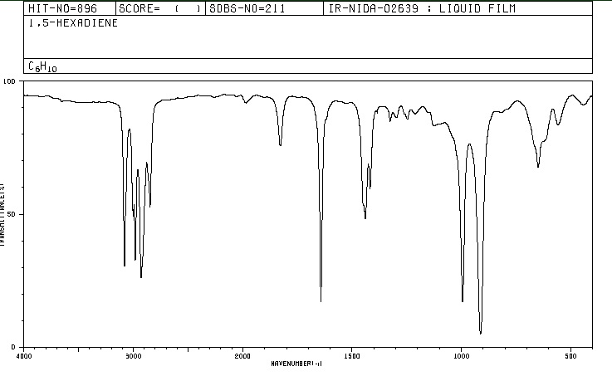  
The molecular formula of 3,3-dimethyl-1-butyne is C6H10. One of its isomers is 1,5-hexadiene. How could you distinguish these two compounds by using their IR spectra (You can find the IR spectrum of 3,3-dimethyl-1-butyne by using the IR spectra simulation)?  
………………………………………………………………………………………………………………………………………………………………………………………………………………………………………………………………………………………………………………………………………………………………………………………………………………………………………………………………………………………………………………………………………………………………………………………………